Create new chatShow chat history
Describe Simulation - Windows Python plant only.vi
Let's talk about Simulation - Windows Python plant only.vi. Here's some information to get you started...
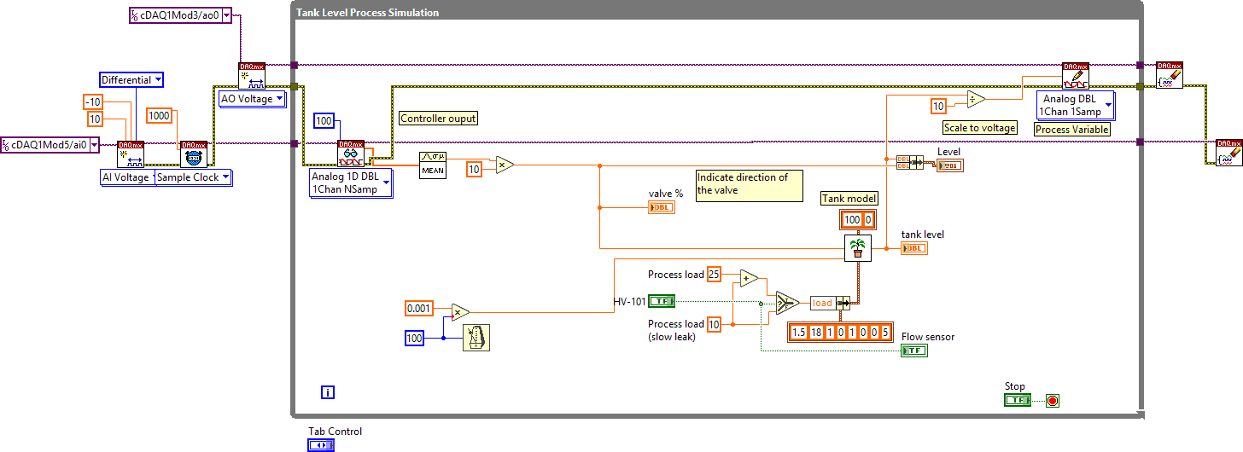
Here’s a breakdown of what your VI does and how it works:
This VI simulates a tank level process with noise, deadband, lag, and deadtime, using DAQmx for analog I/O.

Controls
Name | Default Value | Description
Tab Control | Operation | Switches between Introduction and Operation tabs.
Stop | False | Stops the simulation loop.

Indicators
No explicit indicators are defined at the top level, but within the simulation loop, the following are present:
Name | Description
Level | Shows plant output and related value as a cluster.
tank level | Displays the current simulated tank level.
Flow sensor | Indicates the state of the drain valve (on/off).
valve % | Shows the mean value of the controller output.

How does the VI work?

Initialization
- The VI configures DAQmx analog input and output channels for voltage measurement and generation.
- It sets up timing for the acquisition and output tasks, specifying sample rates and channel configurations.

Main Simulation Loop
- The core logic runs inside a While Loop labeled "Tank Level Process Simulation."
- Each iteration:
  - Reads analog input samples (simulated process variable).
  - Computes the mean value of the input signal.
  - Scales and processes the input to simulate the tank’s physical behavior, including:
    - Adding process noise and load changes.
    - Applying lag, deadband, and deadtime using a plant model subVI.
    - Handling output saturation (limits on actuator signal).
  - The drain valve (on/off) can be toggled to simulate a process disturbance.
  - The controller output is calculated and written to the analog output channel.
  - The simulation updates indicators for tank level, valve position, and flow sensor state.
  - The loop waits for the next time step to maintain a consistent simulation rate.

Shutdown
- When the Stop control is pressed, the VI exits the loop.
- It then clears the DAQmx tasks to release hardware resources.

Key Features
- Process Simulation: Models a tank with realistic dynamics (noise, lag, deadband, deadtime).
- DAQmx Integration: Uses NI-DAQmx VIs for analog input/output, making it suitable for hardware-in-the-loop or pure simulation.
- User Interaction: Allows manual or automatic control, and lets the user introduce process disturbances via the drain valve.
- Visualization: Provides real-time feedback on process variables and control actions.
If you want to explore or modify the simulation parameters (e.g., noise, lag, load), look for the cluster constants and controls inside the loop. For further details on the plant model, check the implementation of the Plant System.vi subVI.
Let me know if you want a deeper dive into any part of the simulation or the DAQmx setup!Copy Text
Good response
Bad response
I need to get a representation of the plant model in python with all inputs and output thoroughly described.
Absolutely! Here’s a thorough description of the plant model as implemented in your LabVIEW simulation, with all inputs and outputs clearly defined—so you can translate it to Python.

Plant Model Overview
The plant model simulates a first-order lag process with deadtime, deadband, noise, and load disturbance. It’s designed for use in feedback control simulations (e.g., tank level control).

Inputs and Outputs
Name | Type | Description
process_parameters | dict | Cluster of all plant parameters (see table below).
reinitialize | bool | If True, resets the plant state to initial conditions.
dt | float | Simulation time step in seconds.
plant_input | float | The manipulated variable (controller output, e.g., valve position, in percent).
output_saturation_range | tuple | (output_high, output_low): Output limits (e.g., (100, 0) for percent).
integrator | bool | If True, uses an integrating process model (optional, default False).
Output:
plant_output | float | The simulated process variable (e.g., tank level, in percent).

process_parameters Structure
Field Name | Type | Description | Example Value
static_gain | float | Process gain (output change per unit input, %/%). | 1.5
lag | float | Lag time constant (seconds). | 18
deadtime | float | Deadtime (seconds). | 1
load | float | Load disturbance (additive, %). | 0
deadband | float | Deadband width (input range with no effect, %). | 1
sensor_noise | float | Standard deviation of sensor noise (output, %). | 0
initial_PV | float | Initial process variable value (output, %). | 0
plant_noise | float | Standard deviation of process noise (internal, %). | 5

Python Function Signature Example
def plant_model(
process_parameters: dict,
reinitialize: bool,
dt: float,
plant_input: float,
output_saturation_range: tuple,
integrator: bool = False
) -> float:
"""
Simulates a first-order lag process with deadtime, deadband, noise, and load disturbance.

Args:
process_parameters: dict with keys as described above.
reinitialize: bool, resets state if True.
dt: float, time step in seconds.
plant_input: float, controller output (e.g., valve position, %).
output_saturation_range: tuple (output_high, output_low), output limits.
integrator: bool, use integrating process model if True.

Returns:
plant_output: float, simulated process variable (e.g., tank level, %).
"""
pass # Implementation here

Input/Output Details

Inputs
- process_parameters: All plant characteristics. Use a Python dict, e.g.:
process_parameters = {
"static_gain": 1.5,
"lag": 18,
"deadtime": 1,
"load": 0,
"deadband": 1,
"sensor_noise": 0,
"initial_PV": 0,
"plant_noise": 5
}

- reinitialize: Set True to reset the plant state (e.g., at simulation start).
- dt: Simulation time step (e.g., 0.1 for 100 ms).
- plant_input: The control signal (e.g., valve position, %).
- output_saturation_range: Tuple (high, low), e.g., (100, 0).
- integrator: Optional; if True, the plant acts as an integrator.

Output
- plant_output: The simulated process variable (e.g., tank level, %).

Implementation Notes
- Deadtime: Implement as a FIFO buffer (queue) that delays the input by the specified deadtime.
- Lag: Use a first-order lag equation:
PVnext=PVcurrent+dtlag[static_gain×(input−deadband)+load−PVcurrent]PVnext​=PVcurrent​+lagdt​[static_gain×(input−deadband)+load−PVcurrent​]

- Deadband: If the input is within ±deadband, treat as zero.
- Noise: Add Gaussian noise to the output (sensor_noise) and/or process (plant_noise).
- Saturation: Clamp the output to the specified range.
- Load: Add as a disturbance to the process variable.
- Initial PV: Used to set the starting value when reinitialize is True.

Example Usage
# Initialize state (e.g., in a class or closure)
plant_state = {
"PV": process_parameters["initial_PV"],
"deadtime_buffer": [plant_input] * int(process_parameters["deadtime"] / dt)
}

# On each simulation step:
if reinitialize:
plant_state["PV"] = process_parameters["initial_PV"]
plant_state["deadtime_buffer"] = [plant_input] * int(process_parameters["deadtime"] / dt)

# Deadtime
plant_state["deadtime_buffer"].append(plant_input)
delayed_input = plant_state["deadtime_buffer"].pop(0)

# Deadband
if abs(delayed_input) < process_parameters["deadband"]:
delayed_input = 0

# Lag
PV = plant_state["PV"]
gain = process_parameters["static_gain"]
lag = process_parameters["lag"]
load = process_parameters["load"]
plant_noise = np.random.normal(0, process_parameters["plant_noise"])
sensor_noise = np.random.normal(0, process_parameters["sensor_noise"])

PV_next = PV + (dt / lag) * (gain * delayed_input + load - PV) + plant_noise
PV_next = np.clip(PV_next, output_saturation_range[1], output_saturation_range[0])
plant_output = PV_next + sensor_noise

plant_state["PV"] = PV_next

Summary Table
Parameter | Python Type | Description | Example Value
static_gain | float | Process gain | 1.5
lag | float | Lag time constant (s) | 18
deadtime | float | Deadtime (s) | 1
load | float | Load disturbance (%) | 0
deadband | float | Deadband width (%) | 1
sensor_noise | float | Output noise (std dev, %) | 0
initial_PV | float | Initial process variable (%) | 0
plant_noise | float | Process noise (std dev, %) | 5
reinitialize | bool | Reset state | False
dt | float | Time step (s) | 0.1
plant_input | float | Controller output (%) | 50
output_saturation_range | tuple | (high, low) output limits (%) | (100, 0)
integrator | bool | Use integrating model | False
plant_output | float | Simulated process variable (%) | 42.3

